DEPARTMENT OF INSTITUTE OF COMPUTING
CHANDIGARH UNIVERSITY

Project: Smart Inventory Management System
Subject Name: Data Structure
Subject Code: 25CAT-151

Submitted to: Professor Kamaldeep Kaur
Submitted by: Tatenda Chikopfa and Susan Masunga
UID: 25BCA10438
UID:25BCA10360
Class:25BCA-2B

1. ABSTRACT
This project presents the design and implementation of a Smart Inventory and Order Management System using fundamental data structures such as Linked List, Queue, and Array. The system efficiently manages inventory records, processes customer orders, and tracks sales in real time.
The Linked List enables dynamic storage of inventory items, the Queue ensures fair order processing using FIFO (First-In-First-Out), and the Array allows fast access for sales tracking. The system demonstrates how theoretical data structures can be applied to solve real-world problems effectively.

2. INTRODUCTION
Inventory management is an essential aspect of business operations, particularly in retail and supply chain environments. Efficient handling of stock, orders, and sales data is necessary to ensure smooth functioning.
Traditional methods often lack flexibility and efficiency. This project introduces a structured approach using data structures to improve performance, scalability, and reliability.
The system simulates a real-world environment where inventory is dynamically updated, and customer orders are processed systematically.

3. OBJECTIVES
- To design an efficient inventory management system
- To implement Linked List for dynamic data storage
- To use Queue for order processing based on FIFO
- To track sales using Array for fast access
- To integrate multiple data structures in one system
- To develop a modular and scalable application

4. DATA STRUCTURES USED
4.1 Linked List
- Used for storing inventory items
- Allows dynamic memory allocation
- Efficient insertion and deletion
4.2 Queue
- Used for order processing
- Follows FIFO principle
- Ensures fairness in handling orders
4.3 Array
- Used for sales tracking
- Provides constant-time access
- Efficient for reporting purposes

5. SYSTEM MODULES
5.1 Inventory Management Module
This is the core module of the system
Functions:
- Add new items
- Delete items
- Display inventory
- Update item details
Data Structure Used: Linked List
Purpose
To store and manage all items dynamically

5.2 Search Module
Handles searching operations
Functions:
- Search item by ID
- Search item by name
Data Structure Used: Linked List
Purpose
To quickly locate items in the inventory

5.3 Order Management Module
Manages customer orders
Functions
- Place order (Enqueue)
- Process order (Dequeue)
Data Structure Used: Queue
Purpose
Ensures orders are processed in FIFO(First in First out)

5.4 Stock Management Module
Maintains items quantity and availability
Functions
- Update stock after order
- Check item availability
- Generate low stock alerts
Data Structure Used: Linked List

5.5 Sales Module
Is responsible for tracking and recording the number of items sold in the inventory system
Functions:
- Tracks total items sold
- Generates sales reports
Data Structure Used: Array

5.6 User Interface Module
Handles interaction between the user
Function:
- Menu-driven interaction
- Input/output handling
Data Structure Used: None (interface layer)

5.7 Data Handling Module
Handles memory and data operations
Function:
- Memory allocation (malloc, free)
- Node creation and deletion
Data Structures Used: Linked List and Queue

6. SYSTEM DESIGN
The system follows a modular architecture:
- Input Layer: User inputs via menu
- Processing Layer: Core logic and operations
- Data Layer: Linked List, Queue, Array
This separation improves maintainability and scalability.

7. WORKING OF THE SYSTEM
- User adds items to inventory
- Items are stored in a Linked List
- Customer places an order → added to Queue
- Orders are processed sequentially
- Inventory stock is updated
- Sales data is recorded in Array
- Reports are generated

8. ALGORITHMS
Add Item
- Create new node
- Insert at end of linked list
Search Item
- Traverse linked list
- Compare values
Place Order
- Insert order into queue
Process Order
- Remove from queue
- Update stock
- Update sales

9. IMPLEMENTATION
The system is implemented in the C programming language using:
- Structures
- Pointers
- Dynamic memory allocation
- Menu-driven logic

CODE
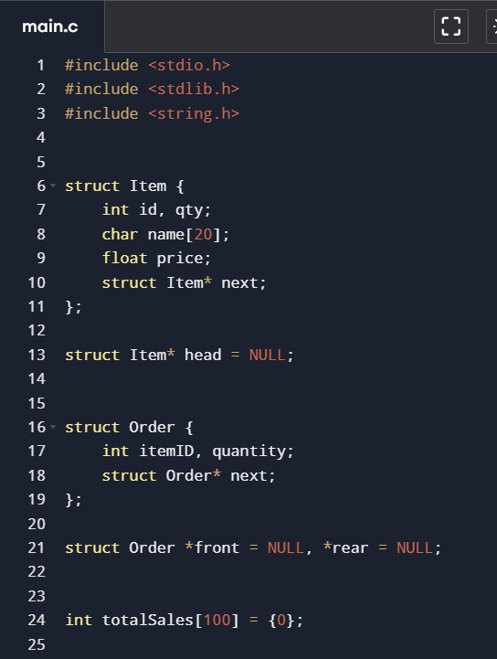
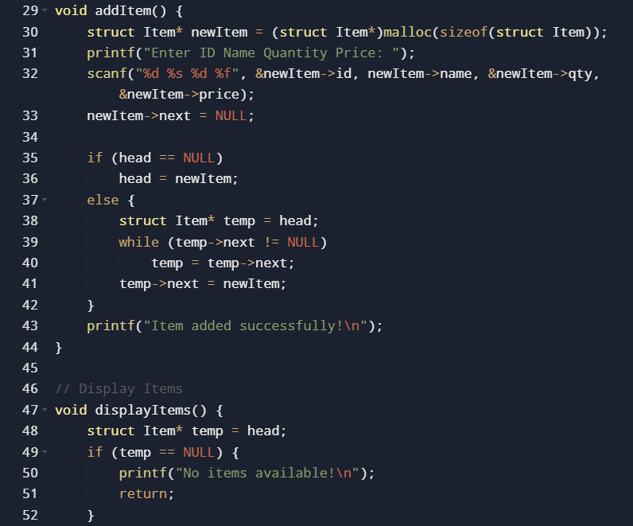
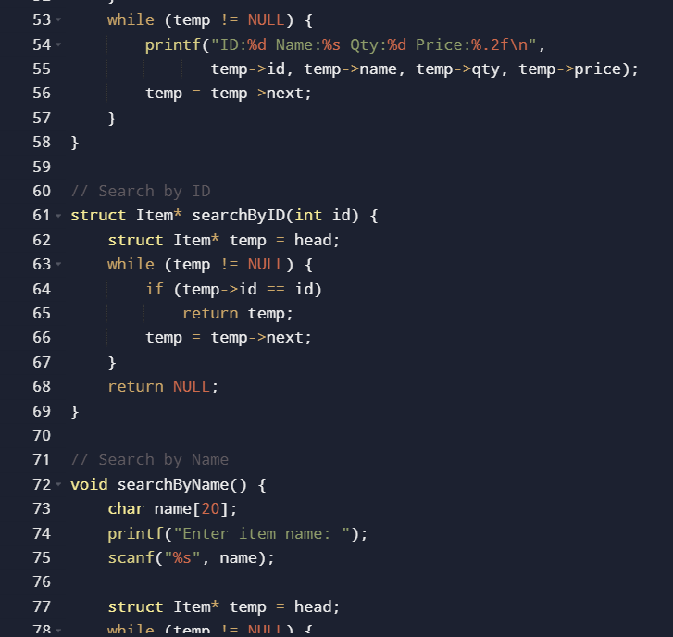
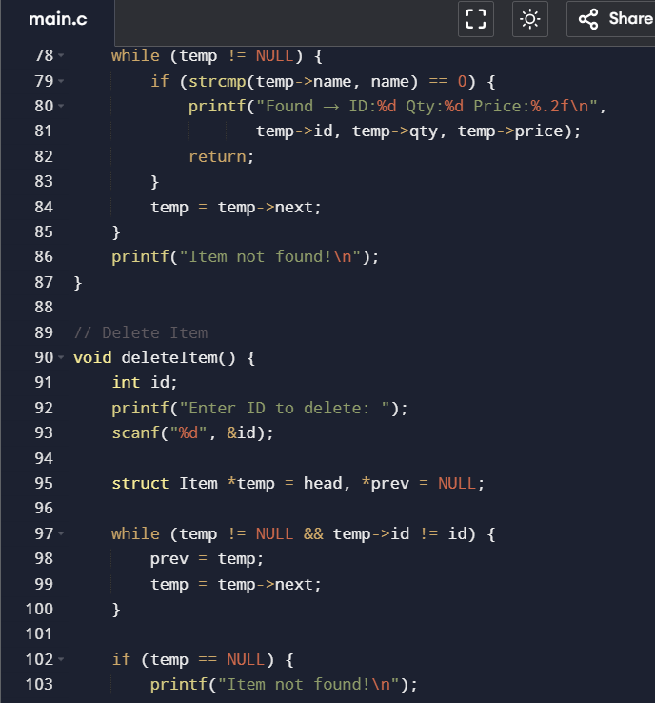
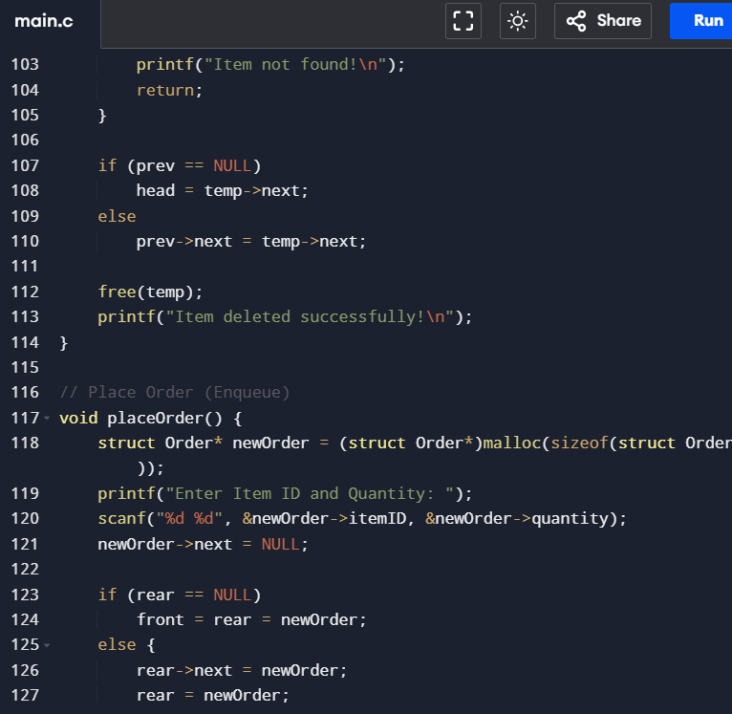
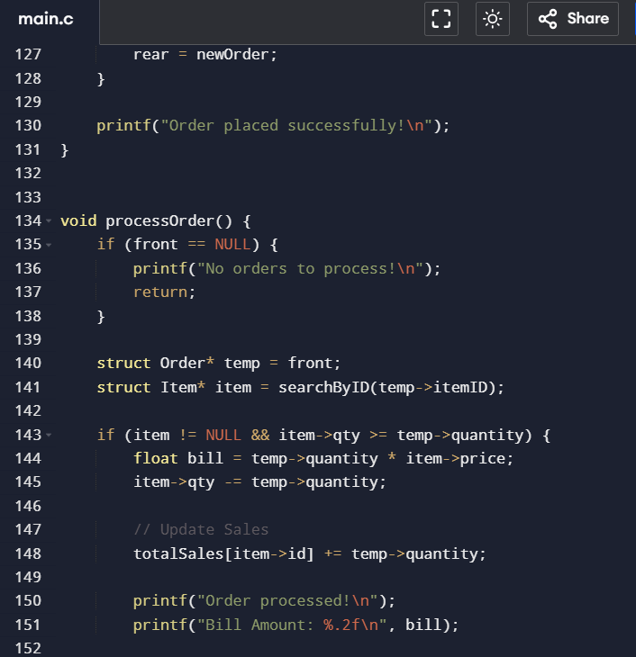
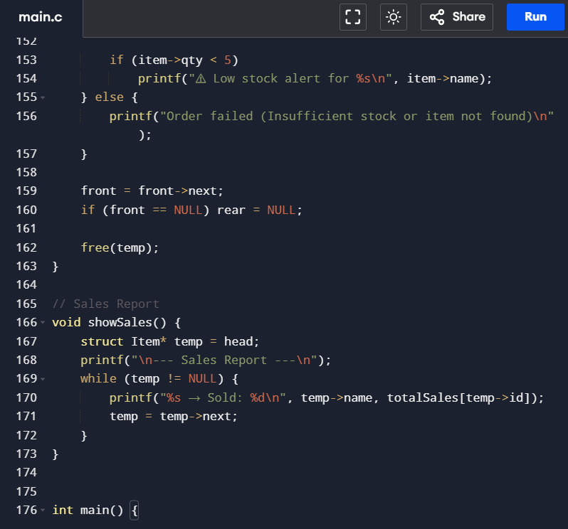
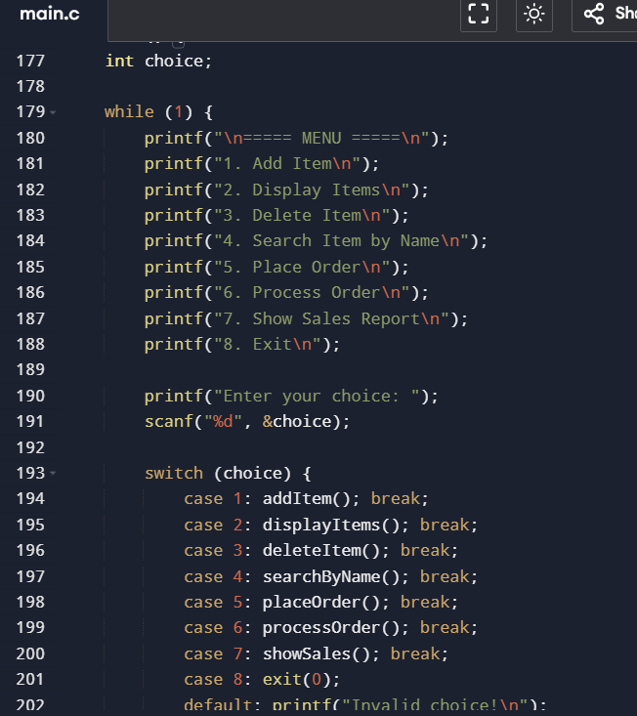
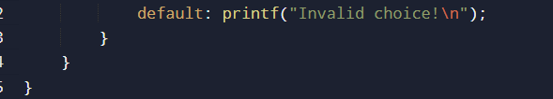
Output
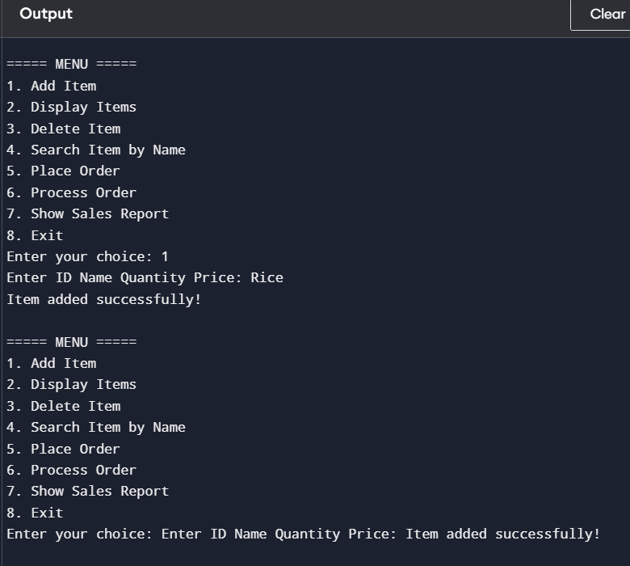c c c

10. COMPLEXITY ANALYSIS
Operation | Data Structure | Time Complexity
Insert Item | Linked List | O(n)
Search Item | Linked List | O(n)
Place Order | Queue | O(1)
Process Order | Queue | O(1)
Update Sales | Array | O(1)

11. ADVANTAGES
- Efficient memory utilization
- Real-time stock updates
- Fast order processing
- Modular system design
- Scalable for future improvements

12. LIMITATIONS
- Console-based interface
- No database integration
- Limited storage capacity
- Not suitable for large-scale systems

13. FUTURE ENHANCEMENTS
- Integration with database systems (SQL)
- Development of GUI interface
- Cloud-based inventory system
- AI-based demand prediction
- Barcode scanning system

14. CONCLUSION
The project successfully demonstrates the practical application of Linked List, Queue, and Array in solving real-world problems. It provides an efficient system for managing inventory, processing orders, and tracking sales.
The modular structure and integration of multiple data structures make the system scalable and adaptable for future enhancements.

15. REFERENCES
- Data Structures textbooks
- C Programming manuals
- Lecture notes

